
Database Management System

EVALUATION - 1 REPORT

Financial Literacy and Portfolio Management in
India

Submitted By :
Name – Anshuman Mohapatra
SAP – 500119016
Roll No. – R2142230609
Batch – 19

Under the guidance of
Ms. Gaytri
(Assistant Professor)
Department of Systems

School Of Computer Science

UNIVERSITY OF PETROLEUM AND ENERGY STUDIES
Dehradun-248007
Oct – Dec , 2024

Index

Contents Page Number

Chapter 1: Abstract 4
Chapter 2: Introduction 5
Chapter 3: Literature 6
Chapter 4: Inference from literature review 7
Chapter 5: Objectives 7
Chapter 6: Analysis 8
Chapter 7: Proposed System 10
Chapter 8: Conclusion 12
Chapter 9: References 13

ABSTRACT

Problem Statement:
Only 27% of India's population is financially literate, leaving a significant majority without the necessary skills to manage their financial lives effectively. This lack of financial literacy hampers their ability to make informed financial decisions, leading to issues such as poor investment choices, debt traps, and limited access to financial services. The vast amount of financial data available necessitates a system that can manage and analyze this data to improve financial literacy.

Analysis Statement:
The current state of financial literacy in India is critical, with only a small fraction of the population having a minimum level of financial awareness. This issue is exacerbated by the lack of comprehensive financial education within the Indian education system, leading to suboptimal financial decisions and economic inequalities. Financial illiteracy affects not only the marginalized but also the middle and upper-middle classes, impacting overall economic growth and stability. Existing research highlights the importance of integrating financial literacy programs into education and the positive impact of such initiatives on individuals and the economy.

Proposed System Description:
The Financial Literacy and Management Platform aims to bridge the financial knowledge gap through an integrated, modular system. Key modules include a User Interface Module for streamlined user interaction, an Education Module offering personalized, demographic-based financial resources, an Asset Tracking Module to monitor various financial assets, a Performance Analytics Module providing actionable insights, and a Database Module for secure data management. This platform will empower users with the knowledge to make informed financial choices, effectively manage their portfolios, and track asset performance, thereby promoting financial self-sufficiency.

Conclusion Statement:
The proposed Financial Literacy and Management Platform is designed to empower individuals by enhancing their financial literacy and capabilities, thereby contributing to improved financial well-being and economic growth. By providing a comprehensive and user-friendly system, the platform aims to bridge the financial literacy gap in India and foster a more financially informed and secure society.

INTRODUCTION

Financial literacy is a critical component in fostering economic growth, promoting individual financial well-being, and enhancing the decision-making capabilities of citizens [1]. Despite its importance, studies show that India faces a significant gap in financial literacy, particularly among young adults in urban areas and rural populations, where financial understanding remains limited [2], [3]. This lack of awareness often results in inefficient money management and a limited capacity for wealth generation.

Financial inclusion is another vital area closely related to literacy, as it facilitates the integration of underserved communities into the mainstream economy. Research emphasizes that financial literacy and inclusion are interconnected, with improved literacy levels enabling more individuals to access essential financial services [4].

The primary challenges in this field include the uneven distribution of financial knowledge across different socio-economic groups, such as working women who exhibit lower literacy levels than their male counterparts, and the youth population which often lacks exposure to financial education [5]. Additionally, the complexity of financial decision-making is compounded by insufficient tools and resources to assist individuals in effectively managing their finances [6]. Furthermore, a significant portion of the population remains outside the formal financial system, hindering efforts toward equitable economic growth [4]. Addressing these issues requires a comprehensive approach that combines education, practical financial tools, and inclusivity.

This paper is organized as follows: Section 2 provides an extensive literature review that highlights previous studies on financial literacy and financial inclusion. Section 3 presents a detailed analysis of the current landscape and identifies key gaps in resources and education. Section 4 proposes a solution that integrates financial literacy education with practical asset management tools, and Section 5 discusses the findings and potential impact of implementing such a system. Finally, Section 6 concludes by emphasizing the need for a unified approach to improve financial literacy and inclusion across India.

LITERATURE SURVEY

Financial Literacy in India

Research highlights that financial literacy levels in India remain low, with only a fraction of the population equipped with adequate financial skills to make informed decisions [1]. A review of the literature by Sciendo emphasizes the critical role of financial education in enabling individuals to understand complex financial products and manage personal finances effectively [1]. This challenge is particularly apparent among young working adults in urban areas, as discussed in a study by Agarwalla et al., which underscores the limited financial awareness among this demographic [2]. Financial literacy also remains inconsistent across regions; for example, Uttar Pradesh and other states in Central India show varying literacy levels, with limited access to formal financial training in rural areas [3].

Barriers to Financial Inclusion and Literacy

Financial inclusion, while closely tied to literacy, faces its own challenges. Financial literacy directly influences individuals’ ability to access banking and financial services, a key factor in promoting equitable growth. Ozili’s review highlights that a lack of financial literacy limits participation in essential banking services, particularly in underserved rural communities [4]. Additionally, Arora’s work on working women in India reveals gender disparities in financial literacy levels, illustrating the need for targeted educational initiatives that consider socio-economic and gender-specific needs [5]. Furthermore, Lusardi’s research shows that individuals with higher financial literacy are better equipped to manage risk, a crucial skill in financial decision-making [6].

Objectives and Inferences

Based on the literature, the objectives of this study are defined as follows:
- To increase access to financial literacy resources across socio-economic groups, with a focus on youth and underserved populations.
- To develop a comprehensive financial literacy program that includes educational tools and a portfolio management system to aid in asset tracking and performance analytics.
- To promote inclusive financial practices by ensuring that literacy initiatives are accessible to all, particularly women and rural populations.

This section provides a foundation for identifying and addressing the gaps in financial literacy and inclusion. The findings underscore the importance of a unified approach that combines financial education with practical tools for managing and analyzing personal finances. Section 3 will discuss the analysis methodology used to assess financial literacy needs in more depth, and Section 4 will present the proposed solution to improve accessibility and usability for all users.

Inferences from Literature Review

The literature highlights several key areas of need:

- Educational Accessibility: There is a strong need for accessible financial education, particularly in rural and semi-urban areas, where literacy rates are disproportionately low.

- Behavioral Change: Financial education programs must address not only knowledge but also behavioral and attitudinal aspects to foster a comprehensive understanding of personal finance.

- Regional Customization: Tailored programs should be developed that consider the distinct socio-economic factors affecting different regions in India.

Defined Objectives

Based on these insights, the objectives of this research are as follows:

- To create a comprehensive financial literacy platform that combines educational resources with practical tools for financial management.

- To develop tailored educational content that meets the needs of diverse demographic groups, specifically targeting low-income and rural populations.

- To promote behavioral change by integrating features that encourage financial planning and decision-making skills.

ANALYSIS

Chosen Parameters for Analysis:

- Educational Reach: Measures the percentage of the target population reached by the methodology or platform (e.g., urban vs. rural, age groups).

- Content Relevance: Evaluates how tailored the educational content is to the needs of specific demographics (urban vs. rural, different income levels, age groups, etc.).

- Interactivity and Practical Application: Measures the extent to which the platform or program includes interactive elements and tools for practical application (e.g., asset tracking, performance analytics).

- Behavioural Impact: Evaluates how effective each methodology is at changing financial behaviours, such as increased savings or improved budgeting habits.

- Adaptability/Scalability: Analyzes the flexibility of the methodology to adapt to different regions and socio-economic conditions in India.

- Comprehensiveness: Assesses how well-rounded the methodology is in covering essential financial topics (e.g., budgeting, investment, credit management).

For each study, a rating is assigned (on a scale from 1 to 10) for each parameter based on the methodology’s description.

Study | Educational Reach | Content Relevance | Interactivity | Behavioral Impact | Adaptability | Comprehensiveness
Sciendo, Financial Literacy in India | 8 | 9 | 7 | 8 | 7 | 9
Agarwalla et al., Urban Youth Literacy | 7 | 8 | 6 | 7 | 8 | 8
Dube and Asthana, Central India | 6 | 7 | 6 | 5 | 6 | 7
Ozili, Financial Inclusion Worldwide | 5 | 6 | 5 | 4 | 7 | 5
Arora, Literacy in Working Women | 7 | 8 | 7 | 6 | 6 | 7

BAR GRAPH FOR THE FOLLOWING DATA

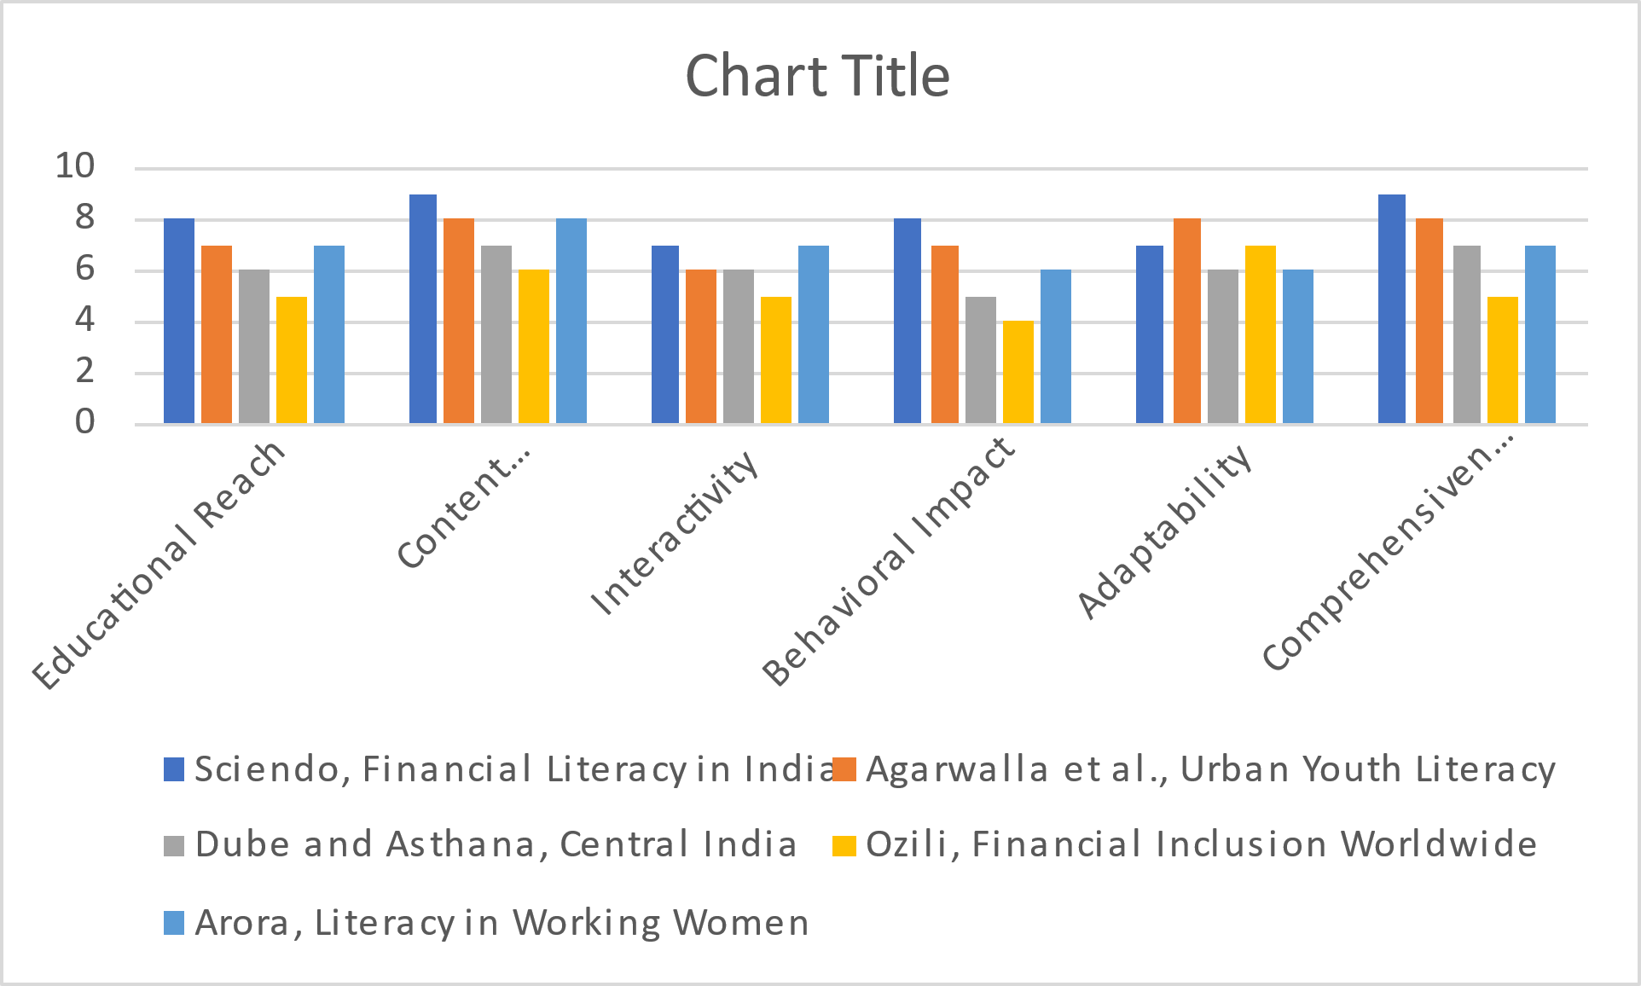

ENTITY RELATIONSHIP DIAGRAM

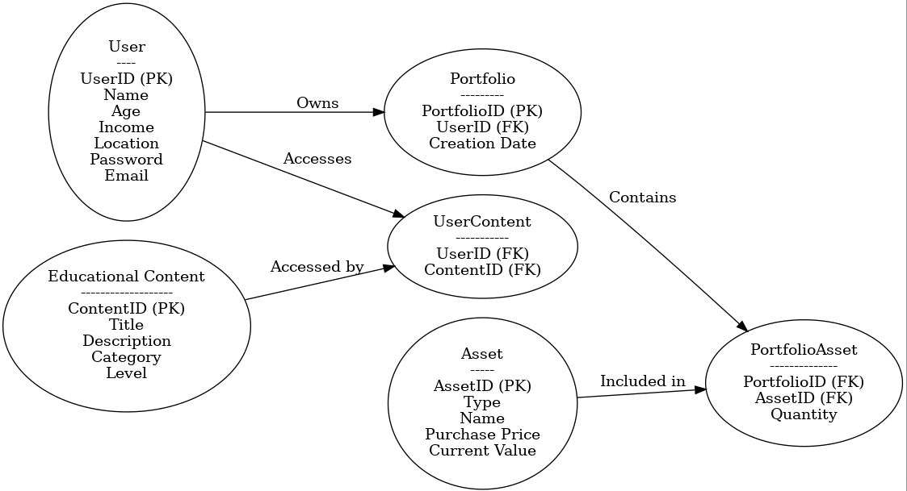
PROPOSED SYSTEM

To improve financial literacy in India by developing an accessible platform that provides educational content, asset tracking, and performance analytics.

Modules:

- User Interface Module
  - Function: Displays educational content, asset information, and portfolio summaries to the user.
  - Output: User input (e.g., asset details, goals), selection of educational resources.

- Education Module
  - Function: Provides tailored financial education resources based on user demographics (e.g., age, income level).
  - Input: User selection from the interface.
  - Output: Educational content (e.g., articles, videos, quizzes).

- Asset Tracking Module
  - Function: Allows users to input and monitor various assets, such as stocks, bonds, and mutual funds.
  - Input: Asset details from the user.
  - Output: Asset portfolio overview.

- Performance Analytics Module
  - Function: Analyzes the performance of the user's financial portfolio and provides insights.
  - Input: Data from the Asset Tracking Module.
  - Output: Performance reports, insights (e.g., asset growth, risk levels).

- Database Module
  - Function: Stores user data, educational content, asset details, and performance metrics.
  - Input: Data from User Interface, Asset Tracking, and Education modules.
  - Output: Retrieved data for real-time updates and analytics.

BLOCK DIAGRAM -

+---------------------+
| User Interface |
+---------------------+
|
v
+-------------------------------+
| Education |
+-------------------------------+
|
v
+--------------------------------------------+
| Asset Tracking |
+--------------------------------------------+
|
v
+-------------------------------+
| Performance Analytics |
+-------------------------------+
|
v
+---------------+
| Database |
+---------------+

CONCLUSION

With financial literacy in India at a mere 27%, there is an undeniable need for a comprehensive system to manage and leverage vast financial data, catering to both financially literate and non-literate segments of the population. This proposed system seeks to bridge the financial knowledge gap by not only educating users but also providing them with essential tools for effective financial management. By allowing users to track and manage diverse assets, including stocks, bonds, and mutual funds, the platform addresses the critical limitations in existing financial literacy programs and introduces practical, hands-on experience with asset tracking and performance analytics.

The system’s integrated approach—combining tailored educational content, real-time analytics, and financial portfolio tracking—promotes informed decision-making and actively supports behavioral change in personal finance. Designed to adapt to diverse user needs, this solution aims to increase financial literacy rates significantly, empowering individuals with the knowledge and resources they need to confidently navigate their financial futures. In doing so, it not only strengthens individual financial stability but also contributes to broader economic resilience and growth.

REFERENCES
[1] Sciendo, "Financial Literacy in India: A Review of Literature," Sciendo, vol. 15, no. 4, pp. 120–130, 2023.
[2] Agarwalla, S. K., Barua, S. K., Jacob J., Varma, J. R. (2013). Financial literacy among working young in urban India. Indian Institute of Management Ahmedabad, 2–27.
[3] Dube, V. S., Asthana, P. K. (2017). A comparative study on Financial Literacy of Uttar Pradesh with Central Zone states in India. IOSR Journal of Business and Management (IOSR-JBM), 19(10), 22-27.
[4] Ozili, P. K. (2021). Financial inclusion research around the world: A review. Forum for social economics, 50(4), 457-479.
[5] Arora, A. (2016). Assessment of Financial Literacy among Working Indian Women. Business Analyst, 36(2), 219–237.
[6] Lusardi, A., (2012), Financial literacy and Financial decision-making, Numeracy, 5(1).
[7] H. N. Butler and J. R. Macey, "Market Funds and Trust Investment Law," Yale Law School Legal Scholarship Repository, New Haven, CT, Tech. Rep. 4514, 1988.
[8] J. A. Schilling, M. H. Schweinsberg, and H. C. Lucas Jr., "New product portfolio management practices: Findings from an exploratory survey,"
[9] J. A. O. Minguela-Rata, R. García-Olalla, and J. Fernández-Méndez, "The determinants of the interest rate margin in banking," *International Journal of Banking, Accounting and Finance*, vol. 3, no. 2, pp. 79-105, 2005.
[10] A. Gunasekaran, C. Patel, and E. Tirtiroglu, "Performance measures and metrics in a supply chain environment," *International Journal of Operations & Production Management*, vol. 21, no. 1/2, pp. 71–87, 2001.
[11] D. Collins, J. Morduch, S. Rutherford, and O. Ruthven, "Finance for the Poor: An Assessment of the Microfinance Sector in India," IFMR, Mar. 2008.
[12] A. Kumar and M. Gupta, "The Role of Digital Libraries in Knowledge Management," *BPAS Journal of Library and Information Science*, vol. 10, no. 2, pp. 45–53, 2023.

